# HTML and CSS

To get started with HTML and CSS, please see following videos.

1. <https://www.youtube.com/watch?v=OZeoiotzPFg>
2. <https://www.youtube.com/watch?v=yyqvXhu-HOc>

## HTML Task

1. What is HTML? Give basic structure of the HTML page.

* HTML is a hyper text markup language i.e. a language used for defining the structure of the web page, marking the items with different tags to define a proper structure.
* Basic HTML structure is as follows:

<!DOCTYPE html>

<**html** lang="en">

<**head**>

     <**meta** charset="UTF-8">

    <**meta** http-equiv="X-UA-Compatible" content="IE=edge">

<**meta** name="viewport" content="width=device-width, initial-scale=1.0">

     <**title**>HTML structure</**title**>

</**head**>

<**body**>

 <**h1**>heading 1</**h1**>

<**p**>Paragraph</**p**>

</**body**>

</**html**>

1. Difference between inline and block level element.

* An inline element only takes up as much width as necessary. Ex: a, span
* While the block element always starts from a new line. Ex: div, p

1. Create an HTML page “index.htm” with following content

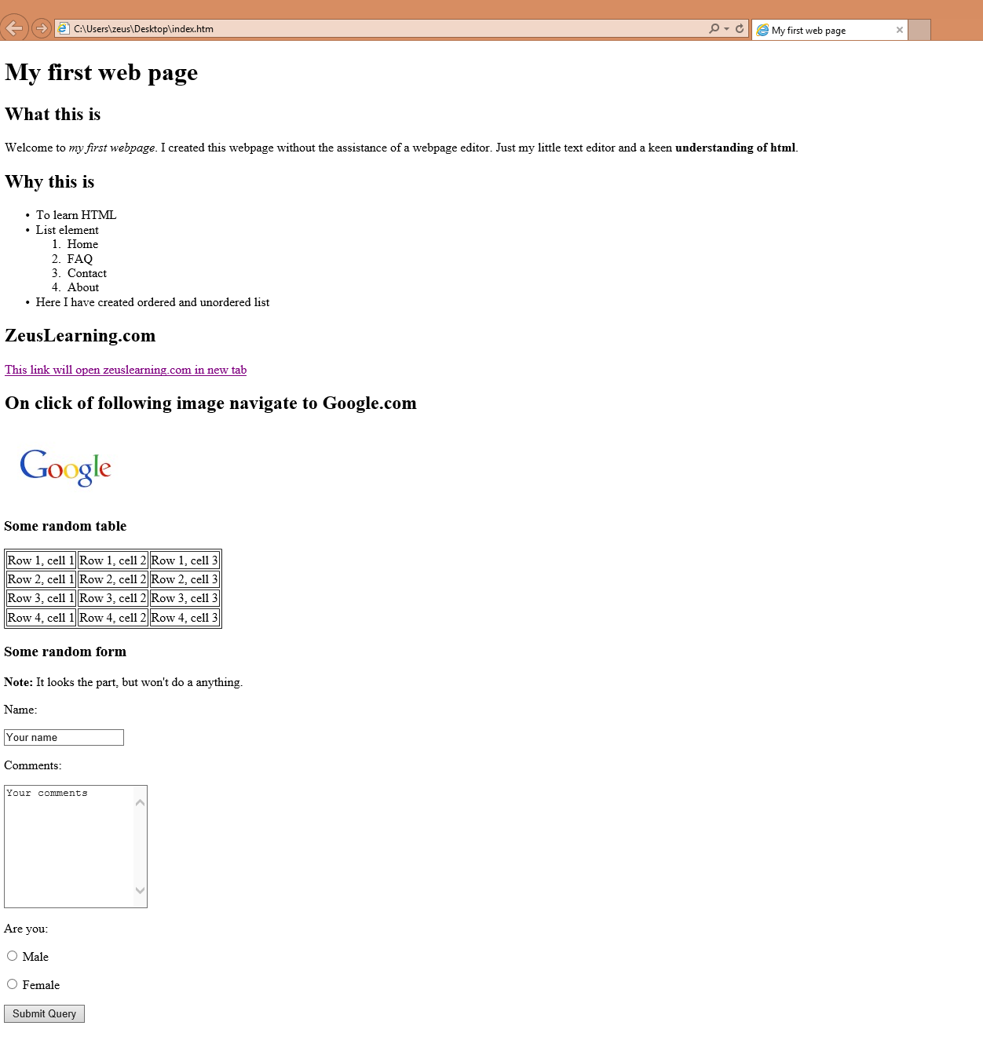

## CSS Task

1. Explain the different ways in which CSS can be applied to HTML, what is the preferred way and why.

* CSS can be added to HTML documents in 3 ways:

1. Inline, using the style attribute inside HTML elements.
2. Internally, using a <style> element in the <head> section.
3. Externally, using a <link> element to link to an external CSS file.

* The preferred way is to use it externally.
* Because same file can be used to give uniform styling to multiple pages in website.
* To explicitly define a tag, class attribute can be used so as to reuse the same styling if needed in another tag.

1. What are different CSS selectors, with example explain Element, Class and Id selectors.

* The different CSS selectors are

1. Element Selector
2. ID Selector
3. Class Selector
4. Universal Selector

* Element Selector is used to write styling for an element(tags).
* ID Selector is used to write styling for an ID(attribute).
* Class Selector is used to write styling for a class(attribute).

1. 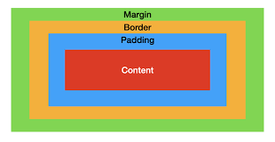With the help of a diagram explain CSS Box Model.

* The CSS box model is essentially a box that wraps around every HTML element. It consists of: margins, borders, padding, and the actual content.

1. The content of the box, where text and images appear
2. Clears an area around the content. The padding is transparent
3. A border that goes around the padding and content
4. Clears an area outside the border. The margin is transparent
5. To HTML page create in the task 1.a, apply following CSS

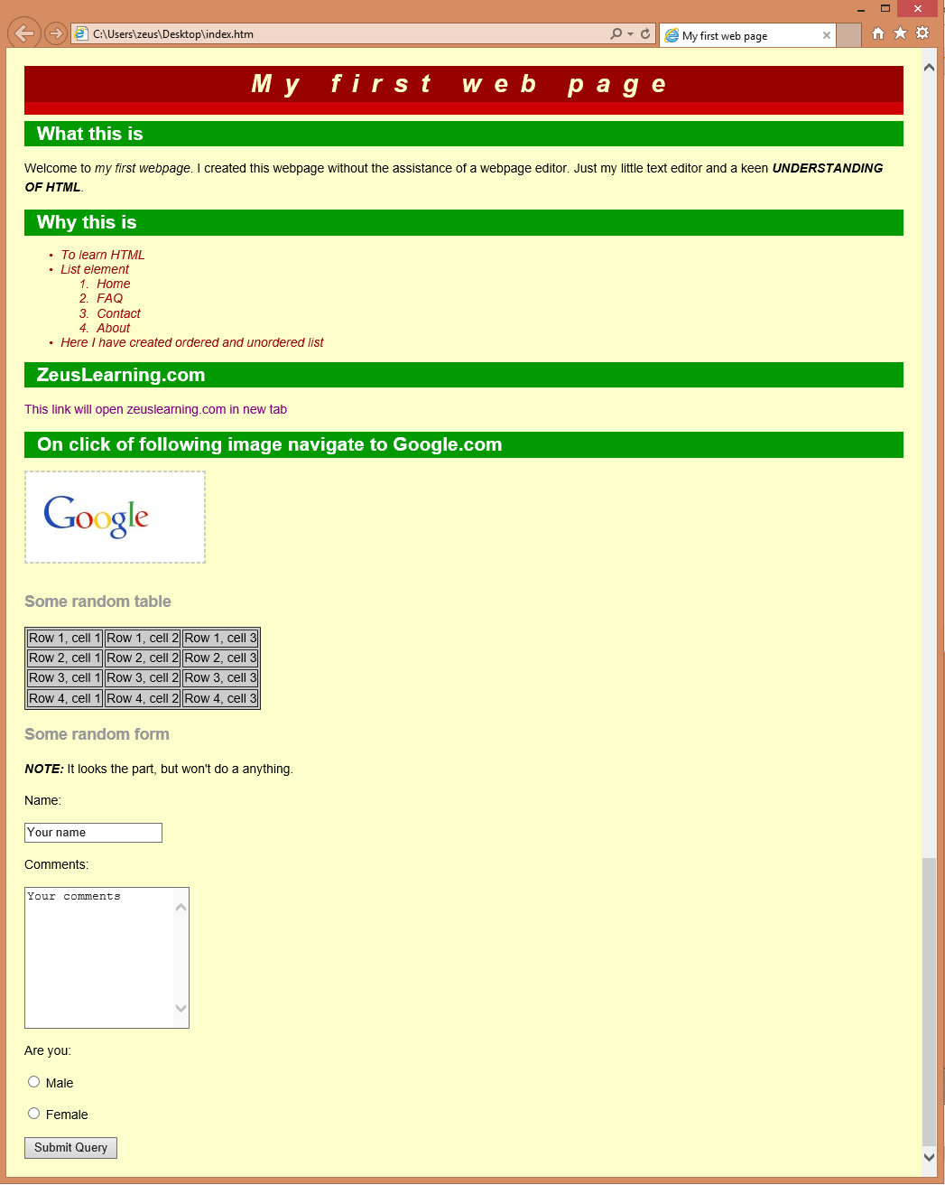

# JavaScript

1. List down ways in which JavaScript commands can be added to a webpage, and what is the preferred way.

* JavaScript can be added to HTML documents in 3 ways:

1. Inline, using the style attribute inside HTML elements.
2. Internally, using a <script> element in the <head> section.
3. Externally, using an <script> element to link to an external .js file.

* The preferred way is to use it externally.

1. To the webpage created in task 2.d, on click of the “Submit” button call the JavaScript function to validate:
   1. Name and comments fields are not empty.
   2. User has selected one entry from the male/female radio button
   3. In case the user has not entered data for the name and comment field or has not selected anything from the male/female radio button, show the alert message “All fields are compulsory” and set focus to the empty first field.